Outputs for 21-26:

21.

Text

0 APPLE

1 bANANA

2 cHERRY

3 dATE

4 fIG

**2222.**

**Values of X:**

**1 2 3 4 5 6 7 8 9 10 11 12 13 14 15 16 17 18 19 20 21 22 23 24 25 26 27 28 29 30 31 32 33 34 35 36 37 38 39 40 41 42 43 44 45 46 47 48 49**

**Values of Y (thrice of X):**

**[3, 6, 9, 12, 15, 18, 21, 24, 27, 30, 33, 36, 39, 42, 45, 48, 51, 54, 57, 60, 63, 66, 69, 72, 75, 78, 81, 84, 87, 90, 93, 96, 99, 102, 105, 108, 111, 114, 117, 120, 123, 126, 129, 132, 135, 138, 141, 144, 147]**

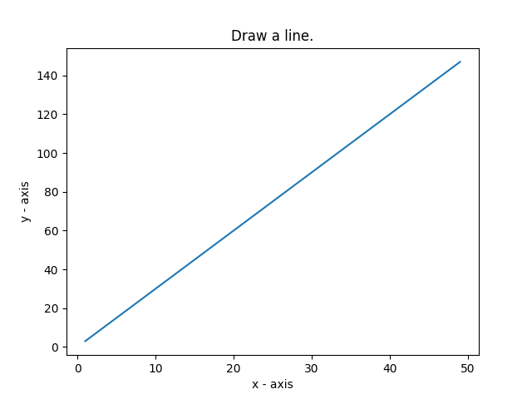

**23.**

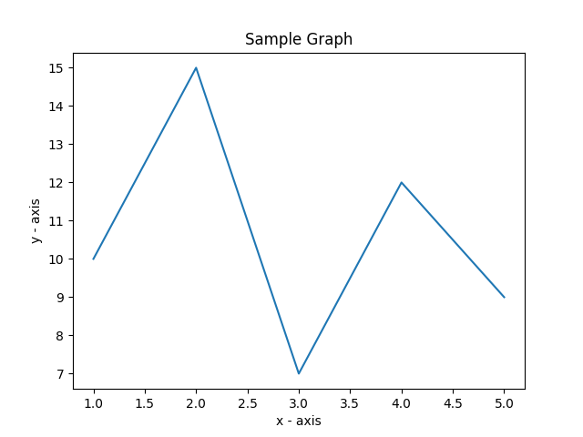

24.

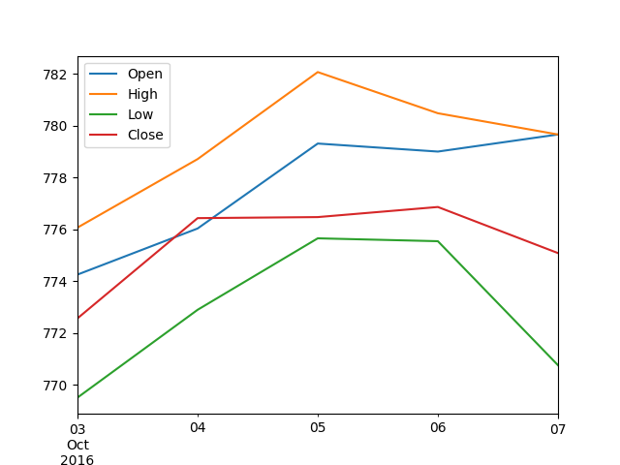

**25.**

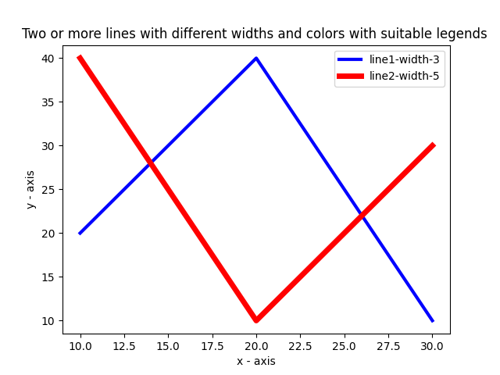

**26.**



**27.**

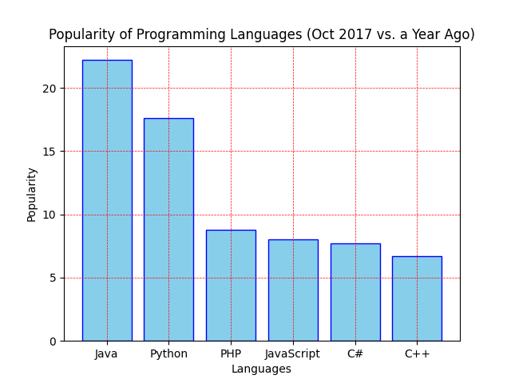

**28.**

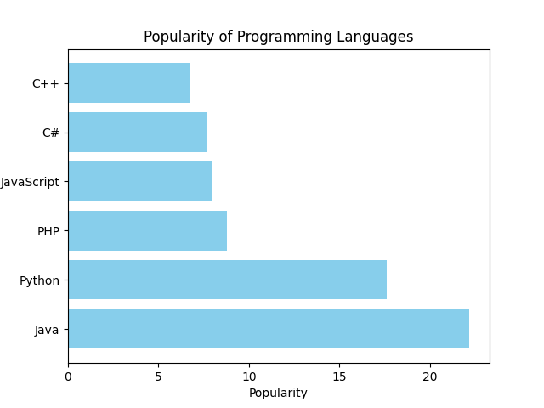

**29.**

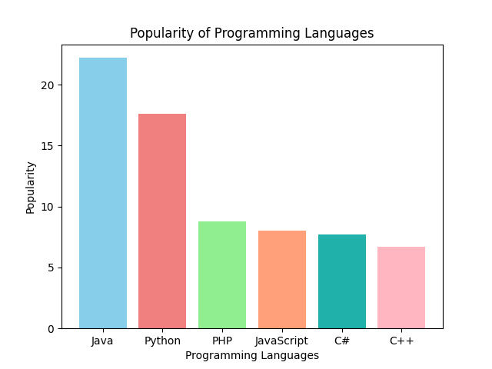

**30**

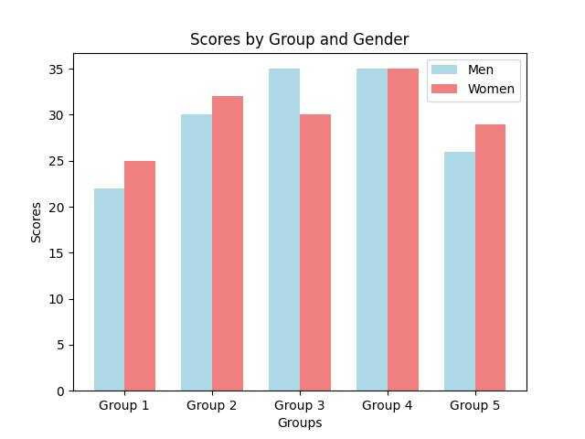

**31**

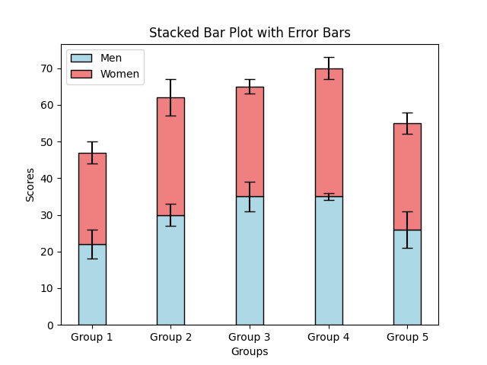

**32**

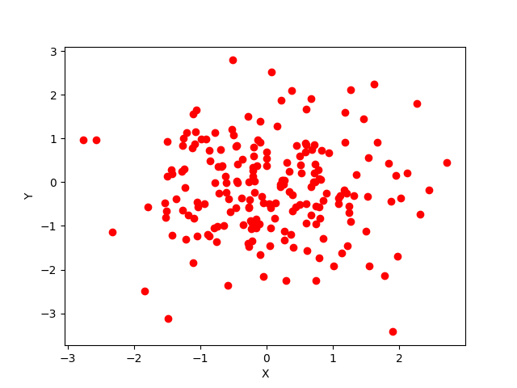

**33**

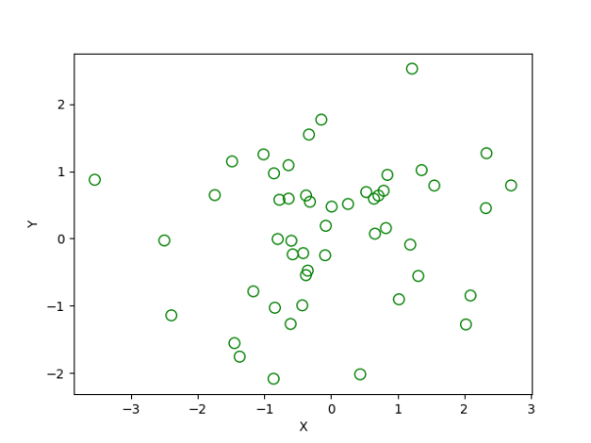

**34.**

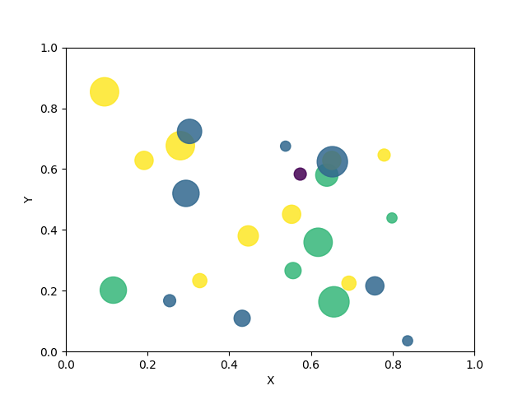

**35**

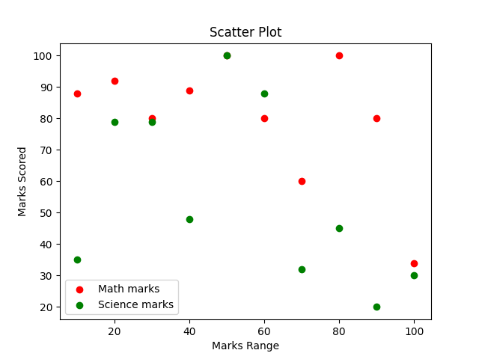

**36**

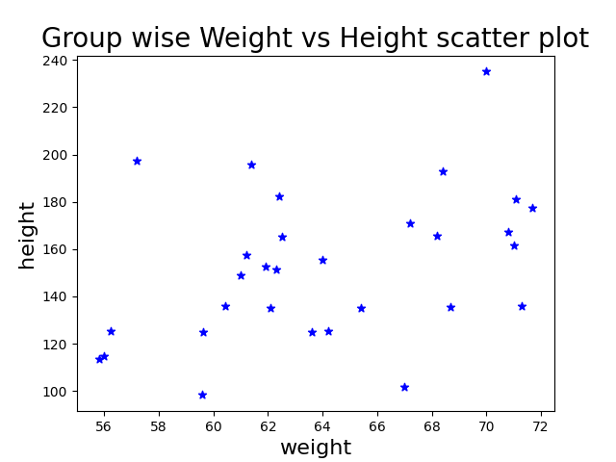

**37.**

**X Y Z**

**0 78 84 86**

**1 85 94 97**

**2 96 89 96**

**3 80 83 72**

**4 86 86 83**

**38.**

**name score attempts qualify**

**a Anastasia 12.5 1 yes**

**b Dima 9.0 3 no**

**c Katherine 16.5 2 yes**

**d James NaN 3 no**

**e Emily 9.0 2 no**

**f Michael 20.0 3 yes**

**g Matthew 14.5 1 yes**

**h Laura NaN 1 no**

**i Kevin 8.0 2 no**

**j Jonas 19.0 1 yes**

**39.**

**First three rows of the data frame:**

**name score attempts qualify**

**a Anastasia 12.5 1 yes**

**b Dima 9.0 3 no**

**c Katherine 16.5 2 yes**

**40.**

**name score**

**a Anastasia 12.5**

**b Dima 9.0**

**c Katherine 16.5**

**d James NaN**

**e Emily 9.0**

**f Michael 20.0**

**g Matthew 14.5**

**h Laura NaN**

**i Kevin 8.0**

**j Jonas 19.0**